Conversations with Claude AI
Prompt 1
“I am building a smart finance assistant that helps analyze people's spending patterns so that they are able to make efficient budgets. Using CSV tools what financial problems/challenges could be solved in this case?”
Responses
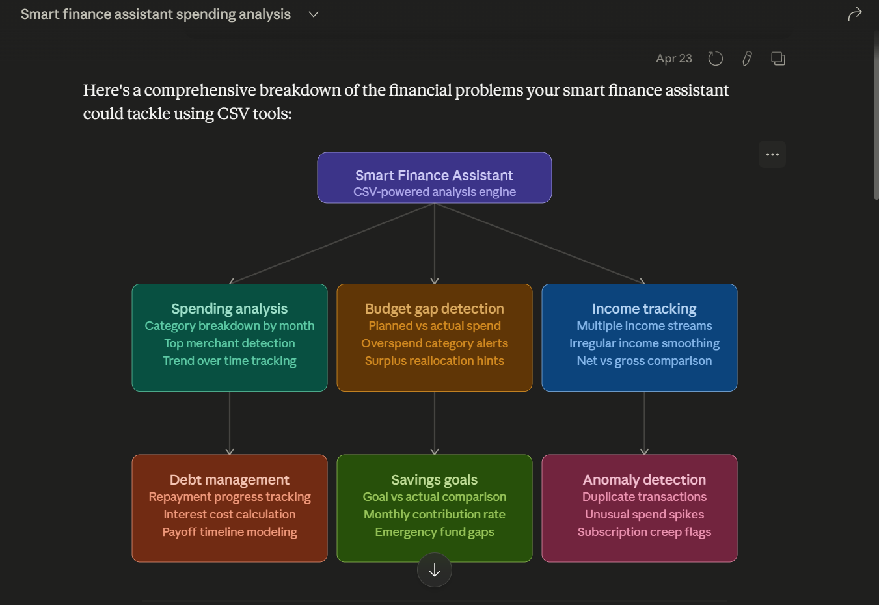
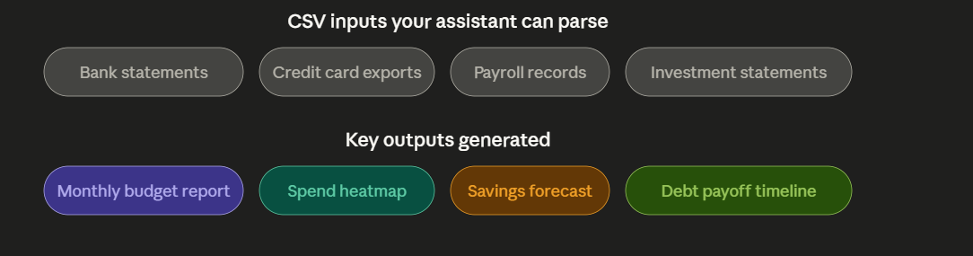

Here's a detailed breakdown of what your CSV-powered finance assistant can realistically solve:
1. Spending pattern analysis — this is the core use case. By parsing transaction CSVs, the assistant can group expenses into categories (food, transport, subscriptions), identify the top merchants draining money each month, and surface trends like "your dining spend has risen 30% over 3 months." This answers the most common user question: where is my money actually going?
2. Budget gap detection — users often set a budget but never measure it against reality. The assistant can compare a budget CSV (planned figures) against a bank statement CSV (actuals), calculate the delta per category, and flag which buckets are consistently over or under — enabling smarter reallocation.
3. Income tracking — especially valuable for freelancers and gig workers. The assistant can parse payroll or deposit CSVs to identify multiple income streams, smooth irregular income into monthly averages, and calculate the effective net-to-gross ratio after taxes and deductions.
4. Debt management — by importing loan or credit card CSVs, the assistant can track repayment progress, model how much interest will be paid at the current rate, and simulate payoff timelines under different monthly payment scenarios (snowball vs avalanche strategies).
5. Savings goal tracking — comparing a savings account CSV against user-defined goals lets the assistant flag shortfalls, calculate required monthly contributions to hit a target by a deadline, and check whether an emergency fund meets the standard 3–6 month benchmark.
6. Anomaly detection — often overlooked but highly valuable. The assistant can scan CSVs for duplicate charges, unusual single-transaction spikes, and "subscription creep" — the slow accumulation of recurring charges users forgot they signed up for.
The diagram also shows the typical CSV inputs your assistant should accept (bank exports, credit card data, payroll files, investment statements) and the outputs users will actually value — budget reports, spend heatmaps, savings forecasts, and debt timelines. Want me to go deeper on the technical implementation of any of these?

Prompt 2
“If my finance problems are spending pattern analysis and budget gap detection, who do you think I can help and what value will my smart finance assistant bring to them?”
Response
